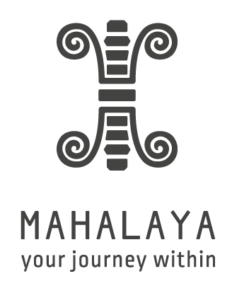

Registration Form
Triple Path to Clarity and Inner Peace - the 21 Stages of Meditation, with Tonie Nooyens (7-15 May 2016)

Please return your completed form to connect@mahalaya-nepal.com

Name
Gender
Date of birth
Email
Phone number (including country code)
Nationality
Accommodation preference  (please delete as appropriate) | Twin sharing  Name of person to share with, if you have a preference – otherwise we will match you to a lovely fellow participant of the same gender:  or  Single room ($280 supplement)
Allergies / food intolerances
Medical alert
(injuries, physical limitations or health issues for us to be aware of)
Previous yoga experience
Where did you hear about this event?
Comments / questions
(Optional field)

Continue to page 2

Liability Release
In any physical activity, risk of injury is possible. Yoga is no substitute for medical diagnosis and treatment. Yoga practice and/or specific poses are not recommended for individuals with certain conditions (e.g., cardiac illness, pregnancy, post-surgery).
I assume the risk of yoga practice and release the teacher(s) and Mahalaya Nepal from any liability claims. I am aware of the physical risks involved with exercise and understand it is my personal responsibility to consult with my doctor regarding my participation. I have no medical condition, which would prevent me from taking part in yoga sessions, I have declared any issues which the teacher needs to be aware of, and I assume responsibility for any risk or injury I may sustain as a result of my participation.

Terms & Conditions
A non-refundable deposit of USD £150 is required in advance to secure your place.
Should you need to cancel before the programme has begun, the following reimbursement structure will apply. We thank you for understanding this policy.
- Cancellation 14 days or less prior to start date, 0% refund
- Cancellation 15 days – 4 weeks prior to start date, 25% refund of the balance (less the non-refundable deposit)
- Cancellation 4 to 8 weeks prior to start date, 50% refund of the balance (less the non-refundable deposit)
- Cancellation more than 8 weeks before due arrival date, 100% refund of the balance (less the non-refundable deposit)
In all cases, the deposit will either be forfeited or you can make a one-time deferral to another Mahalaya event taking place within 12 months of the programme start-date. This deferral can also apply to any non-refundable balance, as above.
Mahalaya may use any pictures or videos taken of participants during the event. This includes digital images which may be posted on our website.
Full terms and conditions are on our website at: www.mahalaya-nepal.com/terms-conditions - please do read these before signing.
I have read the above release and waiver of liability and understand its contents. I have read and agree to the terms and conditions.
Name: (completion of this form, when mailed to us from your email account, stands as a signature)

Date:

Please return your completed form to connect@mahalaya-nepal.com
We look forward to meeting you soon.

